**Project Team 27**

Sprint #1

Week #2

Team Member Name – Swapnil Makarand Joshi

What I did since the last week scrum?

1. Completed remaining basics through demo tutorial
2. Started to learn keyboard and mouse activity in details
3. Started to learn landscape creation

What I plan to do next week?

1. Learn keyboard and mouse activity in depth
2. Explore basics of landscape creation using demo examples

What blockers I have?

None

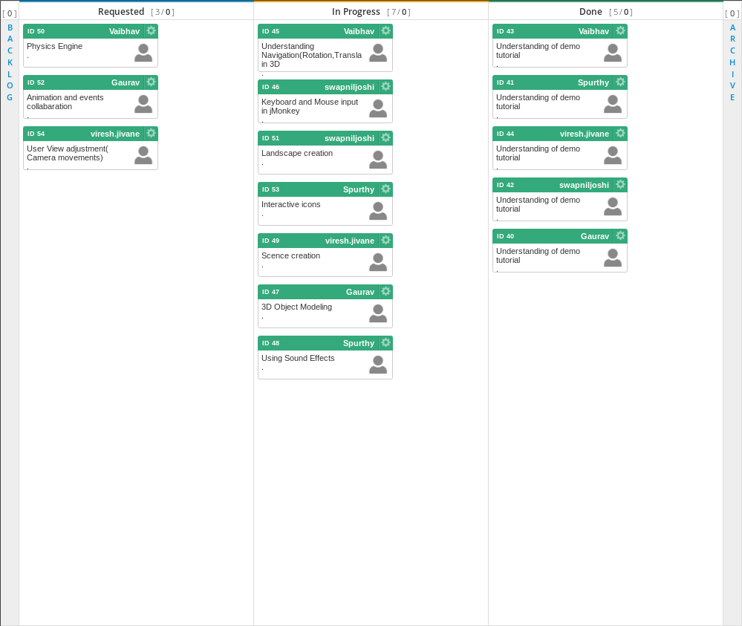

Task board in Kanbanize

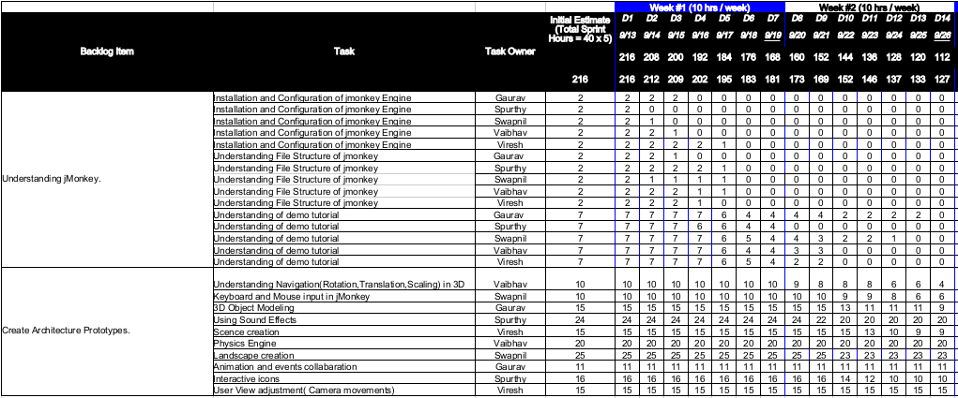

Weekly Standup Report

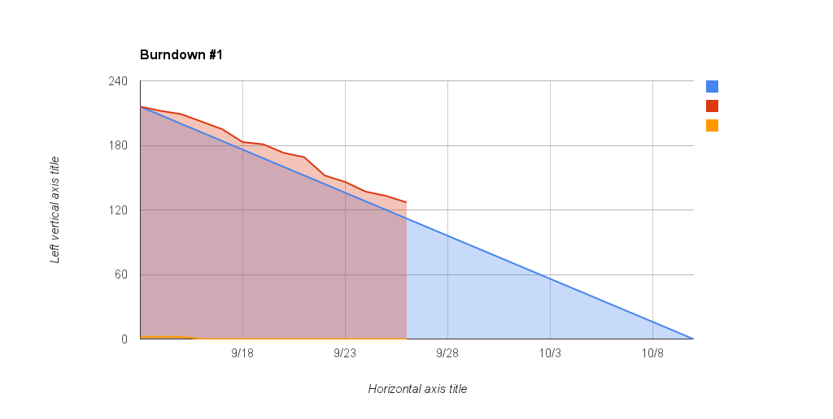

Burndown Chart